**Q1. A reputed pizza company wants to make its foray in launching burgers. You have been appointed as a Marketing Manager & have to develop the 7 P’s of Marketing. What will you do so as to create a USP? Also what will be the advertising strategy for the same?**

**Note: Assumptions should be supported with relevant justification.**

**Ans.**

7 P’ of marketing are:

1. Product:

The company has decided to launch a new product in market (Burger), it's crucial for a pizza specialized firm to launch a burger as a product which can be criticized by people due to non-relational product line in respect to most of the specialized burger producing companies.

Now as a marketing manager it's one of my primary responsibilities to procure the production in respect to demand of the consumers (Target Market).

Following are some of the factors to be controlled and monitored within the organisation and regional outreach:

* Market research is one of the prime factors for identifying customers of the product. Carefully analysing and reducing the gap of the perspective of what they want, instead of what we think they want. The process of market research is carried forward by analysing the current market potential and competitors. Product research is one of the major factor of making certain conclusions about how the market is responding and hence accounting for positives and negatives, which can help in product positioning and branding.
* Customers feedback is one of the key factors of having the most viable product. For a new product launch it is one of the most important account to be taken care off, seeking supervision of quality and consumer perspective. Analysis and further discussions are to be taken to management team for review of the product in both cases of good and bad. It is the best way to track customers need and hence managing the product roadmap for future enhancements.
* It is of high priority to account a balanced approach for product enhancement, to make sure that the offered product is in reach of majority of customers(The target market). Offering a high quality product will boost the price of the product which is an anti factor to be considered for capturing big market.

1. Place:

Though the reputation of pizza company justifies its location credibility, It’s an important attribute to be considered for product positioning. Assuming that all the store has been acquired at prime location, the product can be positioned in well structured manner. In case of supply chain where the product is channelized through different organizations, delivery performance is major factor to be taken into account for product image and customer satisfaction. Place also takes into account the ways of displaying the product to consumer groups which is major marketing factor of the product. Conventionally it has to be displayed via banners and user stories that attract customers to store and helps in buying decision of the product.

* In case of online selling of the product it has to properly displayed with the intuitive user experience and description to help consumer identify uniqueness of the product.
* The delivery method of the product to consumer should be well taken care off, to preserve consumer satisfaction and hygiene in both the cases of self delivery and third party vendor.
* Online methodology should be equipped handy by making it mobile-first application.

1. Price:

A product is only worth what customers are prepared to pay for it. The price needs to be competitive, but this doesn’t mean we have to be the cheapest in your market. When considering the price of your product, it’s important to look at it from the customer’s perspective:

* Price positions us in the marketplace and hence in eyes of customers with respect to competitors.
* Price is a relative concept, more the price, more the quality and service is expected.  
  Everything that the customer sees must be consistent with these higher quality expectations - packaging, environment, promotional materials, website, letterheads, invoices, etc.
* Price also decides the market demography as management wants it to be perceived.

Ex: A high price product will be targeted to posh customers only as only they can afford having them.

1. Promotion:

Promotion is the way a company communicates what it does and what it can offer customers. It includes branding, advertising, PR, corporate identity, social media outreach, sales management, special offers and exhibitions. Promotion must gain attention, be appealing, send a consistent message and - above all - give the customer a reason to choose your product rather than someone else’s.

* Good promotion is not one-way communication-it paves the way for a dialogue with customers, whether in person or online.
* Promotion should communicate the benefits that a customer receives from a product, not just its attributes.
* New channels must be explores from traditional print ads to the latest social media trends. The important principle is to always advertise where our target consumer goes.

1. People:

Everyone who comes into contact with our customers will make an impression. Many customers cannot separate the product or service from the staff member who provides it, so our people will have a profound effect - positive or negative - on customer satisfaction.

* The reputation of our brand rests in the hands of your staff. They must be appropriately trained, well-motivated and have the right attitude.
* All employees who have contact with customers should be well-suited to the role.
* In the age of social media, every employee can potentially reach a mass audience. Formulate a policy for online interaction and make sure everyone stays on-message.

1. Processes:

Many customers no longer simply buy a product or service - they invest in an entire experience that starts from the moment they

discover our company and lasts through to purchase and beyond.

This includes:

* The process of delivering the product or service, and the behaviour of those who deliver it, are crucial to customer satisfaction. A user-friendly internet experience, waiting times, the information given to customers and the helpfulness of staff are vital to keep customers happy.
* Ensuring that our systems are designed for the customer’s benefit, not the company’s convenience.
* Do customers have to wait? Are they kept informed? Is your website fast enough and available on the right devices? Are your people helpful? Is your service efficiently carried out? Do your staff interact in a manner appropriate to your pricing? Are the questions to be well taken care off.

1. Physical evidence:

Choosing an unfamiliar product or service is risky for the consumer, because they don’t know how good it will be until after purchase. We can reduce this uncertainty by helping potential customers ‘see’ what they are buying.

* A clean, tidy and well-decorated reception area – or homepage - is reassuring.

**Q2. Develop a Service Blueprint with the diagram for any organisation in organized**

**retail industry.**

**Ans.**

Service-Blueprinting is a service planning help tool. It can be used for developing new innovative services as well as for improving existing services. The method is also appropriate for ensuring the quality of service processes. It can also be used for new employee training or for showing clients a service cycle overview. The Service-Blueprinting output consists of a graphically-presented overview of the service process and its activities. Service-Blueprinting allows for visualization of

the service development process in its early stages. In each process step, contact points between client and firm(and physical element, if a tangible service) become visible. It is possible to identify failure points and discover areas for innovation as well. This technique eases the identification of cost saving potentials and offers an excellent base for further Service-process management.

Services are difficult to conceptualize in development, due to their intangibility. It not possible to “experience” services with prototypes alone. Service-Blueprinting is a tool that gives a better understanding of the services and their basic processes. The objective is to establish the

activities of the service production in a graphical representation. Service-Blueprinting with its strong client-focus differs from other methods of process analysis. Service Blueprinting supports client satisfaction. Service Blueprinting considers not only the client requirements during the process design, but also the firm’s

internal requirements.

The Service Blueprinting is based on the separation of the service into individual processes that can be assumed separately. The process progress chart is depicted horizontally.Each single component is on a different plane, ordered vertically. Each plane represents a level of closeness to the client, the higher the level the closer the interaction level is to the client.

Planes:

Service Blueprinting differentiates between five degrees of client interaction and integration

(See Figure):

* The client interaction line separates the process steps of the service activities that the client carries out independently
* The visibility line separates the service activities that the client can see from the service activities which are hidden from view. Above the line, the process components that can be seen, heard, smelt or perceived are ordered.
* The internal interaction line separates activities that imply immediate relation to the client’s order from support activities. Support activities serve as the preparation for the primary activities but do not belong to the client’s order. Examples are the maintenance of a ski lift or the cleaning of an office.
* The control line separates the preparation activities from the general management activities.

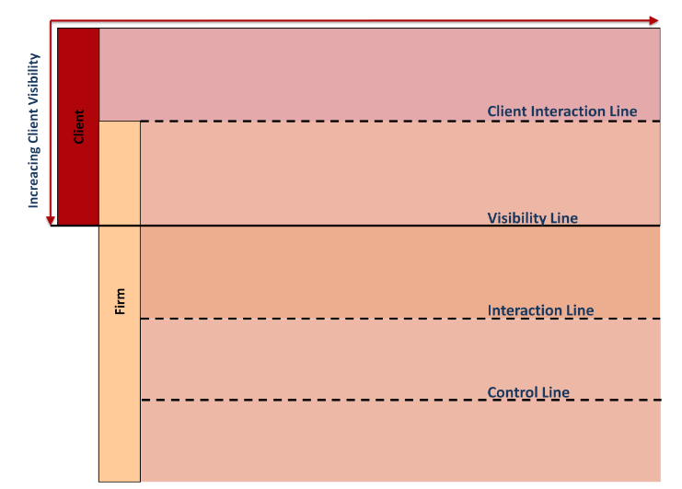

Service Blueprinting differs from other approaches on process modeling and analysis, in that the vertical distribution is related to the responsible areas of each division. Assignment of responsibilities for each process step is also not shown visually. Here the client focus is to be considered for many clients it is unimportant which divisions they need to be in contact with to get their service order properly accomplished.

Service blueprinting for new services:

A client-oriented process course (Service Blueprint) for new services is shown in the following four steps. Further development will be completed step-by-step and is based on the client’s process.

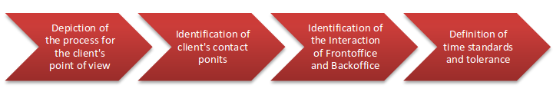

1. Definition of the ideal customer interaction process, from initial contact to the end of service interaction.
2. Identification of the contact points between the client and service provider. This includes all client-perceivable process steps performed by the service.
3. Identification of the interactions between the front office and the back office.
4. Definition of time standards, tolerance levels and of the resources required.

Service blueprinting for existing services:

The Service Blueprinting procedure is appropriate for existing services.

By illustrating and analyzing the current status of the service process, it is possible to see areas of improvement within the service sequence. Creating visual representations aid process improvement by showing the flow and highlighting potential points for incremental adjustment.

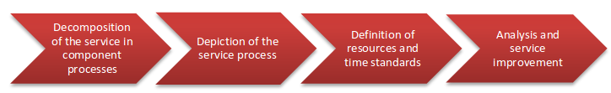

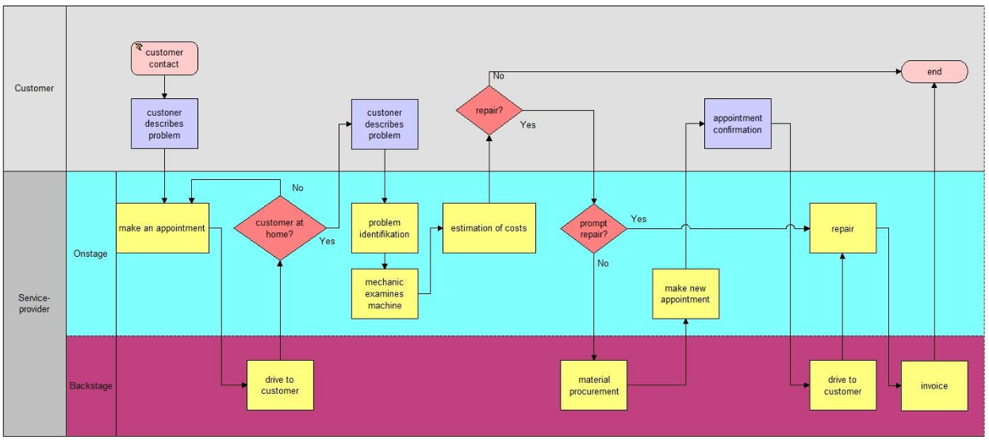**Q3. Read the following Case & solve the questions given:**

**Amol booked a table in a restaurant for 12 people at the beginning of the Diwali period to celebrate the festive season with his family and friends. He had been a regular visitor to Moti Restaurant and had developed loyalty for this place famous for South Indian food. Most of his friends were from the South, so he preferred to treat them at Moti. Another reason for his selection was that the patron of Moti, Raj Kumar knew him well. Since he was regular visitor, he was quite confident that this dinner would be a success. Three days before the scheduled get-together dinner Amol spoke to Raj Kumar and asked him to increase the booking to 16. He looked busy but informed Amol it would be quite in order and he looked forward to seeing Amol and party later that week. As per programme's, all Amol’s friends met at his residence at 7.00 p.m. on the appointed day and after having a cup of coffee left for Moti to be there at the scheduled time of 8.30 p.m. They were all relaxed and exchanged jokes on their way and reached the restaurant at 8.20 p.m. With slight difficulty, they located parking place at three different locations for the four cars in which they were traveling. The guests arrived at the restaurant on time and Amol was taken aback to find that the table has been set only for 12 persons. Raj Kumar came over seeing a large group gathered around the small table laid in one comer of the dining room. Amol reminded Raj Kumar of his earlier conversation which he had with him three days ago. He asked him to recollect that the booking had been increased from 12 to 16, and suggested that it may be an oversight that he had forgotten to set the table for 16 people. Amol then asked him to reset the table immediately for 16 people to avoid any embarrassment to him and his guest. To**

**Amol's great amazement and embarrassment Raj Kumar denied that Amol has asked for a booking for 16 people. He, rather, told Amol that he had not phoned him at all this week to make amendments in the booking. "You must have been mistaken" said Raj Kumar. Amol tried to make him admit his mistake but Raj Kumar was too rigid and continued to take a stand that he had not received any such call and that the booking was for 12 people only. The restaurant was full and Amol asked Raj Kumar to resolve the matter as his guests had been standing for more than ten minutes. Raj Kumar expressed his helplessness and said there was nothing he could do at the moment. At such time, Amol knew that there was nowhere else they could go at this time. Amol and his wife along with another couple opted to wait and let 12 members of the group seat themselves. It was after a long wait that they could be accommodated with the group. This could happen only when the guests sitting next to them left after their meal. All of them settled for the dinner but discussions mostly centered around the service provided by the restaurant. At the end of the dinner Amol checked the bill and did not leave any tip for the waiters. Before leaving the restaurant, Amol met Raj Kumar in private and explained him that he would not be visiting him again. Raj Kumar admitted that he may have been hasty but thought Amol was being unreasonable as it was his busiest evening and he could make allowances. Amol never visited the restaurant again and his friends too stayed away. They narrated this incident to many people.**

**Questions:**

**a. What according to you are the causes of poor delivery in this case?**

**Ans.**

As described above in the case, Amol booked a table for 12 initially and upgraded it to 16 later on phone call, Rajkumar on other hand received the notification but being busy forgot to note it down conventionally and missed the acknowledgement due to busy schedule and claimed that e hasn’t received any notification regarding an upgrade for 16 people. Now, either of them cannot be blamed for the mismanagement happened at the place because neither a phone call is a conventional way to book a party place and either was rajkumar’s way of dealing with the bookings on phone call. This is clearly a case of causality nature went absurd at time of presentation.

Causes of poor delivery are:

* No conventional way of booking tables for specific occasions.
* Bad order handling methodology.
* No spare sitting arrangements for casualties like described in the case.
* No booking invoice was generated at the time of booking and order upgradation.
* Bad customer handling practice. Being arrogant with customer is not the way of dealing with regular customer like amol.

**b. What steps could have been taken to rectify the situation as a service recovery**

**Strategy?**

**Ans.**

Following steps could have mades the process easier:

* Having a online booking portal where a customer can adjust its booking is a great option to have. Though it's not a feasible way unless the firm income is high enough to provide the facility because maintaining a portal is an expensive process.
* Some additional space must be adhered to be ready for such situations specially on the special occasions where even extra guests are expected to arrive.
* Parking place must be guided by a man held responsible for the facility to avoid problems faced by customers.
* In case of any booking order an invoice should be generated to help maintain consistency and further problems.
* In case the order is updated a new invoice should be generated at the spot with respect to previous order detail to avoid miscommunication cases.
* Communications should be held on mail instead of telephone to help maintain reliability and consistence in operation of booking.